Viscoelastic Parameter Optimization Methods

Goal

The goal of this work is to develop baseline viscoelastic (VE) parameters for the hindlimb muscles by matching passive and active experimental joint motion. For a single muscle, tension is developed according to the equation,

.

where T is muscle tension, Kse is series element stiffness, B is damping, L is muscle length, Lrest is muscle resting length, Al is the length-tension factor, and Am is the stimulus-tension force.

This work seeks to optimize the parameters Kse, Kpe, and B for thirty-eight muscles in order to reduce the sum-squared difference between joint motion from simulation and experimental hanging leg experiments. This results in an optimization input vector with 3x38 terms. For a maximal (20 nA) stimulus, I want the muscle to be able to achieve maximum tension (Fmax). When at 0 nA, I want the muscle to be purely passive (Am = 0).

The values for Fmax come from the literature while Lrest values come from the model directly. The model is moved through an exaggerated range of motion to determine Lmin and Lmax for each muscle. Lrest is set as the halfway point between these two values.

Optimizer

The optimizer for this process uses the patternsearch function in Animatlab. This process perturbs input values in a “mesh” pattern in order to find parameter combinations that reduce a cost function. Patternsearch is useful for problems that do not have a defined gradient, such as a simulation with discrete outputs. In addition to using the mesh polling method, a mesh adaptive direct search enhances the optimization process.

Linear constraints are applied to ensure that the tension profiles in Animatlab do not become asymptotically unstable. This limitation, related to the size of the physics timestep, dt, is described in detail in a 2020 Living Machines and primarily describes. Essentially, these linear constraints ensure that the physics timestep constraint,

,

is true for all muscles.

Motivation

The activation parameter, Am, represents a sigmoidal relationship between stimulus and tension which is important for controlling muscles by applying voltage to the motoneuron. Specifically, the maximum value of Am (STmax) and the steepness of the slope it represents have the largest impact on the relationship between stimulus and tension. The stimulus-tension equation takes the form,

.

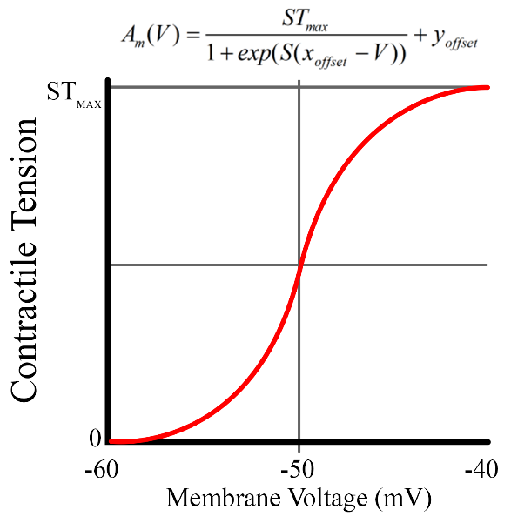

where S is steepness, xoff is the voltage offset (set to -50mV for all muscles), V is the motoneuron voltage, and yoff is the output offset.

Originally, I started by defining a desired output range [0, 1.05Fmax] and determined the necessary stiffness to be ~1200. Incorporating these values into the ST curve resulted in a steeper curve.

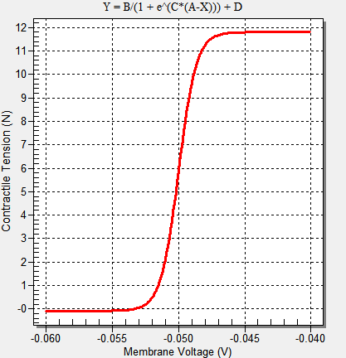

The issue with a steep ST curve was twofold.

1. When running experiments where the hindlimb is actuated by muscle stimulation, I noticed that the maximum tension for any muscle was much smaller than Fmax. This has to do with the term  in the tension equation. Essentially, this term is fighting to reduce the current tension, while Am is trying to increase it.
2. The steepness of the curve was so high that it effectively turned muscles into switches. This is difficult to derive tension profiles for because it causes tension to switch on and off rather than gradually shift values over stride.

To address the first problem, I decided to dynamically set STmax based on viscoelastic parameters in order to balance the inhibitory tension term with the activation term. To accomplish this, I set

.

This assumes that at steady-state and resting position, the muscle can generate Fmax by stimulating the motoneuron. The result is that, in some cases, STmax is dramatically larger than Fmax. This exaggerates the second problem related to the steepness of the curve.

To address the second problem, I decided to set the curve steepness to a specific value such that the switch-like behavior is avoided. To accomplish this, I chose to have the ST curve range from [0, .98STmax]. This reduces the output range of Am slightly but the less-steep curve should allow me to generate smoother force profiles. To find the necessary steepness for this range, we solve equations at the end values.





which results in values of  and .

Now, when I optimize Kse, Kpe, and B for each muscle, I set  and .

This makes the optimization a bit less accurate in the stimulation phase. Although the passive portion still matches as well as my previous baseline VE values, the stimulated portion tends to overshoot the desired trajectory. I think this is because I am assuming a stimulus of 20 nA for all muscles when, in reality, the experimental stimuli varied between muscles. With this assumption, the output tension is always . So the tension is only dependent on the ratio of parallel to series stiffness, which seems to vary only slightly as the solution converges on the passive motion. As long as the stimulation phase is capable of generating *at least* the motion from experiments (i.e. the leg overshoots its target), I can be confident that I could recreate the desired motion by using the ST values I have calculated.

It is possible that I can add seven voltage values to the optimization to get the stimulus portions to match better.